GIT TASK
Establish a new directory, populate it with script files, initiate an empty repository on GitHub, convert the local directory into a Git repository, and link it to GitHub for pushing the code into the repository.Perform merge, rebase, stash commands in following github repo.
Commands Used:
- a new directory, populate it with script files:
mkdir bhavi
cd bhavi
touch script1.sh script2.sh
echo "#!/bin/bash\necho Hello World" > script1.sh
echo "print('Hello from Python')" > script2.sh

- initiate an empty repository on GitHub, convert the local directory into a Git repository, and link it to GitHub for pushing the code into the repository:
git init
git status
git add .
git commit -m “files added”
git remote add origin https://github.com/bhavitharamohan/GIT-TASK.git
git remote -v
git branch -M main
git push -u origin main
- Perform merge, rebase, stash commands in following github repo:

git checkout -b feature
echo "echo Feature work" >> script1.sh
git add script1.sh
git commit -m "Add feature work"
git checkout main
git merge feature-branch
git push
git checkout -b rebase-branch
echo "Rebase example" >> script2.sh
git add script2.sh
git commit -m "Rebase commit"
git rebase main
echo "Temporary change" >> script1.sh
git stash
git stash list
git stash apply
git status
git log --oneline --graph --all
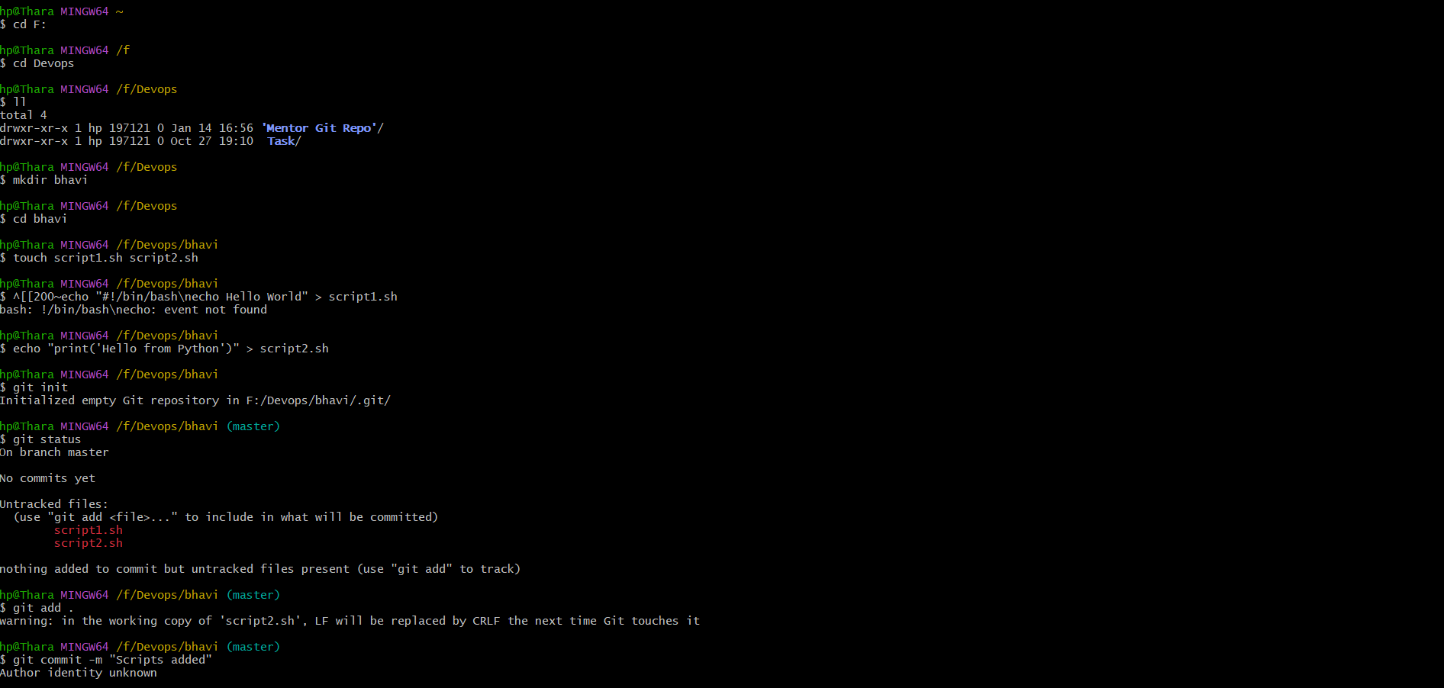

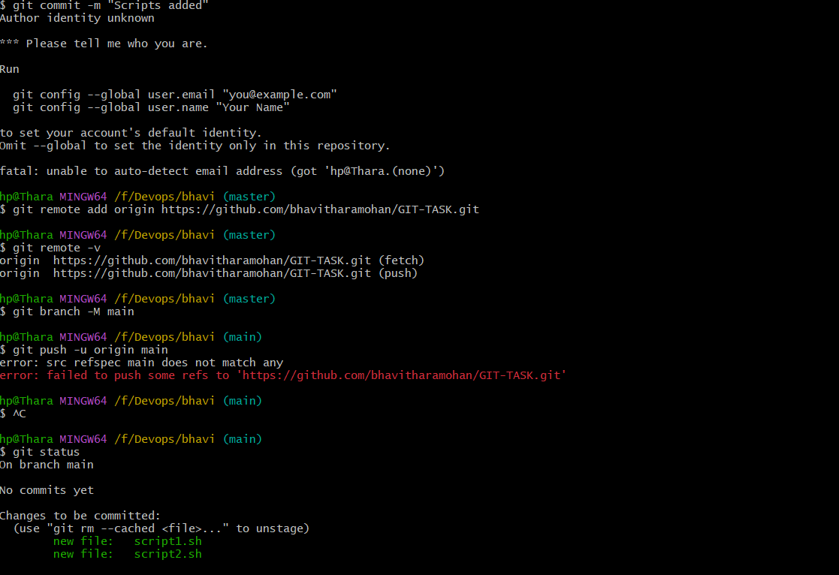

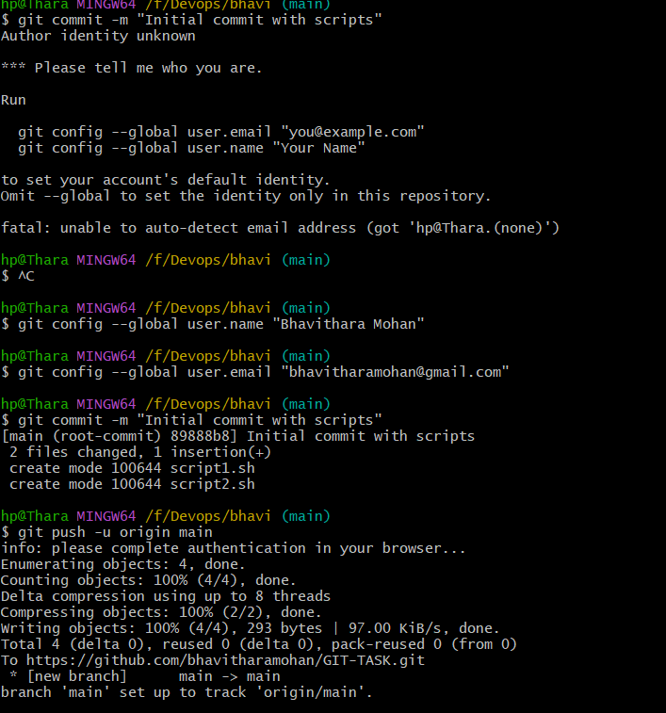

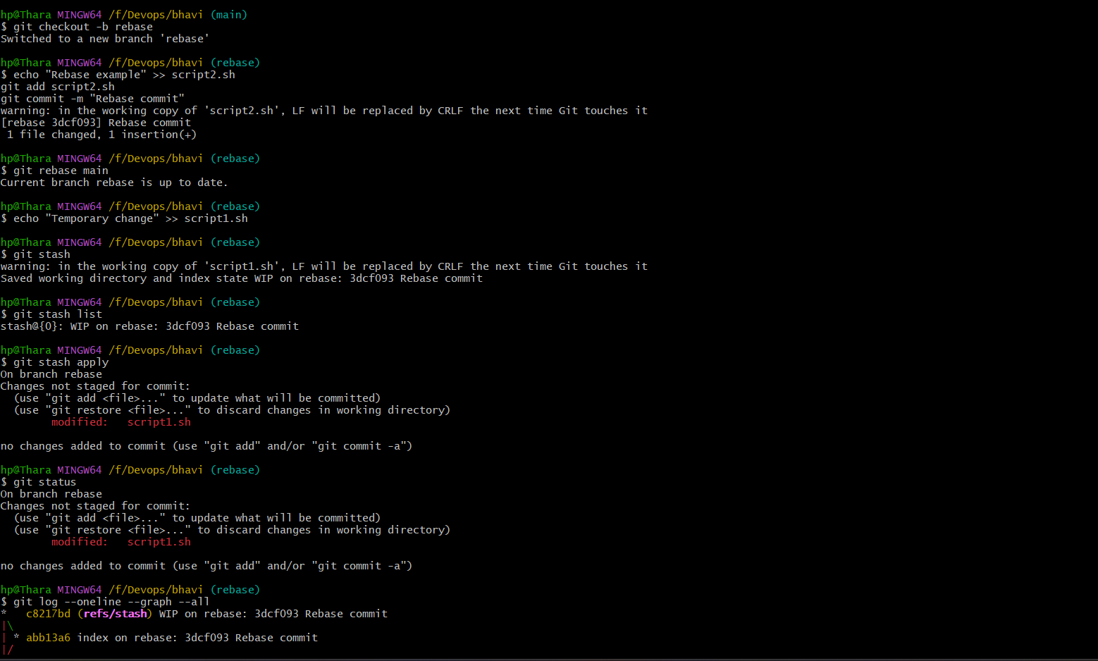

git init → local repo
git remote add origin → link GitHub
git push → upload code
git merge → combine branches
git rebase → rewrite history cleanly
git stash → park unfinished work

Repo link : https://github.com/bhavitharamohan/GIT-TASK

